Developing an Electronic Training Material in English for Ecotourism for
Wangkho Batik Community Enterprise, Khanom District,
Nakhon Si Thammarat Province

Jittima Choopun^{a*} Napadon Sornpakdee^{b} Khemnatee Srisuklom^{c} Kritchaya Thepsuriwong^{d}
ªCollege of Industrial Technology and Management,
Rajamangala University of Technology Srivijaya, Thailand
*Corresponding Author Tel.: 0894698707, E-mail address: Jittima.c@rmutsv.ac.th
Abstract
The tourism industry continues to develop rapidly and has opened a large workplace in Khanom District, Nakhon Si Thammarat Province. Staff who work in the tourism and hospitality industries are highly aware of the importance of English and have to have good English communication skills in their workplace. This study aimed to study the needs of English language skills for ecotourism and to develop electronic training material in English for ecotourism for Wangkho Batik Community Enterprise, Khanom District, Nakhon Si Thammarat Province. The participants were 20 members of the Wangkho Batik Community Enterprise. There were four stages in the production of the training material: (1) conducting a preliminary study to determine the needs for English language skills training; (2) analyzing the needs, developing, and piloting the training equipment; (3) implementing the material with the staff who work in the tourism and hospitality industries; and (4) evaluating and revising the material. There were three instruments used to obtain the research data: a questionnaire, electronic training material in English for ecotourism, and an interview. Findings from the study showed that electronic training material can encourage staff who work in the tourism and hospitality industries to master their English skills. It can encourage them to be more autonomous practitioners. However, the common limitations included a weak internet connection and low computer skills. Furthermore, the results of this study would help trainers and language teachers when they develop and integrate technology into English training materials.
Keywords: electronic training material, English for ecotourism, Khanom District
Introduction
Khanom, the northernmost district of Nakhon Si Thammarat province, is located approximately 100 kilometers from the city of Nakhon Si Thammarat and 60 kilometers from Surat Thani. Khanom district has rich natural resources and offers a wide range of tourist attractions. The district has several beaches, spanning approximately 9 kilometers along the Gulf of Thailand. There is an ideal destination for visitors who seek to learn the nature, wisdom, and valuable culture of the local community. The tourism industry in Khanom district is developed rapidly resulting in the establishment of employment opportunities.
Wangkho Batik Community Enterprise is an enterprise that originally started with the goal of empowering the community and increasing their sources of income. Presently, it has become an integral part of community-level tourism, engaging in various agricultural and ecotourism activities. The members of the enterprise aware and recognize the significance of English proficiency and strong communication skills within their community. To foster and enhance human resource development to support tourism, it is important to involve local community members in tourism management. With the growing number of foreign tourists, it becomes more crucial for community members to have knowledge and professional skills as tour guides. Having English proficiency plays a vital role in this context. By attaining English language skills, community members can effectively communicate with foreign visitors, and contribute to a positive tourism experience. To achieve this goal, it can be facilitated through the implementation of language training course and material specifically designed for community members involved in tourism.
Currently, there is a wide range of online English training courses, but not all of them suit for specific groups or individuals. Specifically, English electronic training material has been developed to address the requirements of the tourism workforce. Additionally, there has been a growing focus on the use of electronic textbooks in educational settings. These digital resources incorporate a range of multimedia features offering learners advantages that may not be available in traditional books. These advancements are reshaping the nature of language learning, moving away from static texts and towards more interactive experiences on digital screens. As a result, learners have flexibility to extend their learning anytime and anywhere. It has been argued that these features make electronic textbooks highly beneficial for language learning and teaching (Almekhlafi 2021; Liu and Leveridge 2017).
Based on the explanation above, it is necessary for the researcher, who takes the role of an English language teacher, to adapt teaching methods and encourage tourism staff to enhance their English language proficiency. This can be achieved by providing training and materials that combine English language teaching with advancements in computer technology. Members of the enterprise and other tourism staff can utilize and study this material independently.
Research Method
This research aimed to investigate the English language skills needed for ecotourism and develop electronic training materials in English for Wangkho Batik Community Enterprise in Khanom District, Nakhon Si Thammarat Province.
In this section, the researcher provides research questions, an overview of the participants, research setting, research instruments, data collection method, and data analysis. However, it should be noted that the study was not approved by the Human Research Ethics Committee of the institution. The researchers have undergone training in Ethical Conduct in Human Research organized by the university in 2021 and have obtained a certificate.
To ensure ethical practices throughout the research, prior to collecting data, the participants were informed that their involvement in the study would not have any negative impact on their work. Moreover, their rights were protected throughout the research project.

Figure 1. The researcher introduced training materials in English on ecotourism to members of Wangkho Batik Community Enterprise.
Research questions
The research comprised two main research questions:
1. What are English language skills needed for ecotourism? and
2. How can electronic training materials in English be developed for the Wangkho Batik Community Enterprise in Khanom District, Nakhon Si Thammarat Province?

Participants
In this study, the participants were divided into two groups using a purposive sampling method. The first group comprised 50 key informants who completed a questionnaire during the preliminary study. The criteria for selecting the first group of participants were as follows: 1) members of Wangkho Batik Community Enterprise, 2) representatives from Khanom Non-Formal and Informal Education, 3) officers from the Subdistrict Administrative Organization, 4) local residents living in the vicinity of Wangkho Batik Community Enterprise, and 5) staff responsible for planning ecotourism activities.
The second group consisted of 20 members from Wangkho Batik Community Enterprise who served as trainees during the implementation of the material. The researcher selected participants who volunteered to participate. This group included 2 males and 18 females, with ages ranging between 35 and 55 years old. The majority of them had completed higher vocational degrees and bachelor's degrees.
Research setting
Wangkho Batik Community Enterprise was initially established by 12 members who shared a common goal of empowering the community, applying King Bhumibol Adulyadej's sufficiency economy philosophy as a guiding principle for their livings, and diversifying their sources of income. Presently, the group has expanded to 20 members. The enterprise engages in various activities such as planting organic rice and mushrooms, raising local chickens, organizing ecotourism tours, and preserving local fruits and products. Notably, a significant focus is placed on teaching the art of Batik making to children, youths, and visitors. The office of Wangkho Batik Community Enterprise is located in Kuanthong subdistrict, Khanom district, Nakhon Si Thammarat.
Research instruments
In an attempt to answer the research questions, this study used a quantitative study for data collection and analysis. Three research instruments were used for data collection.
1) To answer the research question concerning English language skills needed for ecotourism, the researchers employed a questionnaire as a tool of data collection. To gather insights from a wide range of individuals involved in Wangkho Batik Community Enterprise, the researchers distributed the questionnaire to key informants, including members of Wangkho Batik Community Enterprise, government officers, individuals, local residents, and staff responsible for planning ecotourism activities. The data collection was carried out by the researchers themselves with the assistance of two research assistants. The duration of the data collection process was two weeks.
The questionnaire was prepared in Thai to minimize language barriers and potential misunderstandings. It was divided into three parts. Part I focused on gathering participants' demographic information. They were requested to provide details such as their gender, educational background, occupation, and monthly income. Part II focused on assessing English language skills needed for ecotourism. Participants were asked to evaluate their needs for various English language skills using a checklist and a five-point Likert scale, ranging from 1 (lowest need) to 5 (highest need). Part III consisted of one open-ended question, which provided participants with opportunities to express additional suggestions or feedback that were not covered in the questionnaire.
The researchers conducted an analysis and interpretation of the data collected from the questionnaire responses. For each of English language skills needed for ecotourism, the researchers calculated both the averages and the standard deviations (SD). In addition, the researchers identified the overall level of need that participants considered for each of English language skills and determined which needs are most frequently considered by participants.
2) 5 units of electronic training material in English for ecotourism developed by the researchers and the content of each unit based on a needs analysis from a preliminary study. The researchers used obtained findings as a framework for materials development. The researchers continued to the next stage of electronic training material development procedure by designing the contents of the material. Overall, the materials covered 5 units and focused on English communication skills related to effectively engage with guests, describe places in the community, promote local products, and present local food and local handicrafts.

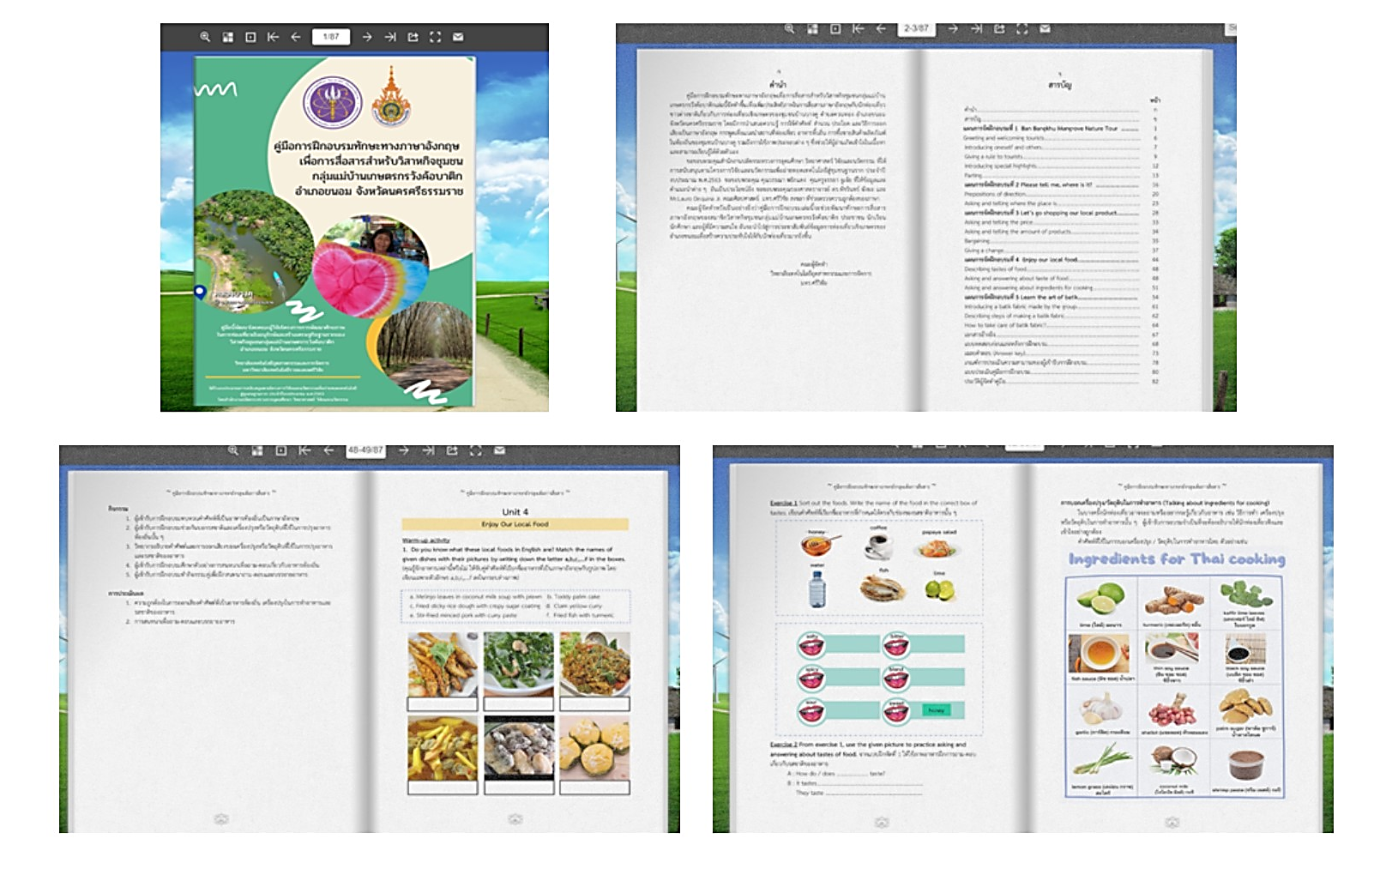
Figure 2. A sample of electronic training material in English for ecotourism uploaded on AnyFlip

Since English is not the first language in Thailand, the explanation within the electronic training material in English for ecotourism is provided in both Thai and English to promote effective learning for individuals with varying language backgrounds. This ensures that participants have scaffolds to understand the content effectively.
Moreover, to facilitate comprehension, the material is designed with visually engaging elements such as effective visuals and graphic organizers. These visuals aid in conveying information and concepts in a clear and concise manner. Additionally, the font used in the material is carefully chosen to optimize readability, ensuring that participants can easily engage with the content and follow along with the lessons.
In the stage of online materials production, the researcher submitted the material to three experts to check the content validity and the appropriateness of the content. Three experts were involved in the study: two English language lecturers and computer technology experts. After revising, the researchers utilized AnyFlip, a digital publishing software solution to convert the material into a digital publication and share a link for easy access by others. It is then pilot-tested to ensure its effectiveness and suitability for the participants.
The pilot testing is conducted with a small group of participants. The researchers chose a diverse group of participants, provided them with the electronic materials, observed as they used the materials, and took notes on their actions, comments, and any issues they encountered.
The final step was the evaluation and revision of electronic training materials. To gain the feedback and reflection, the researchers asked the participants to express their opinion towards the constructed online materials and analyzed the data. Based on the evaluation results, any necessary revisions or
improvements are made to enhance the quality and relevance of the training material.
The procedure of the electronic training material in English for ecotourism development is presented in Figure 3.
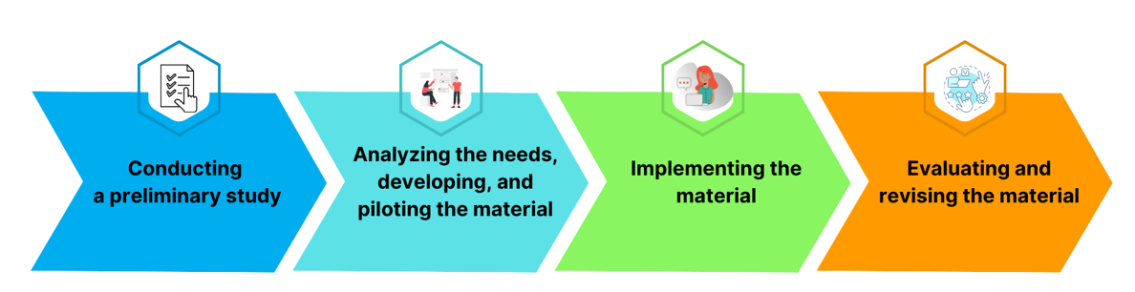
Figure 3. The procedure of the electronic training material in English for ecotourism development

3) Interviewing was used to study the participants' opinions regarding the development of electronic training materials in English for ecotourism.
Data analysis
The researchers analyzed the results of the questionnaire in the preliminary study by utilizing descriptive statistics, which included the average and standard deviations (S.D.).
Results and discussion
Based on the research questions regarding the English language skills needed for ecotourism, the researchers utilized a questionnaire as a data collection tool. The results of the data analysis are presented in the table below:

Table 1. The overall mean and standard deviation of the participants’ needs for English language skills training for ecotourism.

English language skills needed for ecotourism |  | S.D. | Level of need
Greeting and parting | 4.50 | 0.611 | high
Greeting and welcoming guests | 4.47 | 0.643 | high
Giving rules, obligations, and asking for participation | 4.46 | 0.642 | high
Giving information about food and beverages | 4.46 | 0.626 | high
Giving information about local products and souvenirs | 4.46 | 0.642 | high
Asking and answering about the prices of products and services | 4.45 | 0.657 | high
Providing instructions for emergency cases or accidents | 4.44 | 0.641 | high
Describing the steps involved in producing a local product | 4.43 | 0.685 | high
Providing information about tourist attractions in the community | 4.43 | 0.685 | high
Giving information about locations and directions | 4.42 | 0.654 | high
Introducing oneself and others | 4.41 | 0.683 | high
Providing information about local traditions and culture | 4.40 | 0.667 | high
Providing information about the history and background of a specific place | 4.38 | 0.678 | high
Providing information about tourism and recreational activities | 4.33 | 0.805 | high
Overall average | 4.43 | 0.666 | high

As shown in Table 1, the overall findings revealed that all English language skills were highly needed. Based on the responses, greeting and parting (x¯= 4.50, S.D.=0.611) was identified as the highest needed skill. Additionally, the participants expressed a strong need to practice greeting and welcoming guests (x¯= 4.47, S.D.=0.643), giving rules, obligations, and asking for participation (x¯= 4.46, S.D.=0.642), giving information about food and beverages (x¯= 4.46, S.D.=0.626), and giving information about local products and souvenirs (x¯= 4.46, S.D.=0.642) respectively.

In order to develop the electronic training materials in English for ecotourism, the researchers utilized the findings obtained from the preliminary study as a framework for material development. The researchers designed the contents and language focus of the material, which encompassed a total of 5 units. The detailed contents and language focus for each unit are presented in Table 2:

Table 2. The contents and language focus of electronic training materials in English for ecotourism.
Unit | Contents and language focus
Unit 1 : Ban Bangkhu mangrove nature tour | 1.1 Greeting and welcoming guests  1.2 Animal and plants in mangrove  1.3 Giving rules and advices  1.4 Parting
Unit 2: Please tell me, where is it? | 2.1 Places in community  2.2 Prepositions of direction  2.3 Asking and saying where the places
Unit 3: Let’s go shopping our local product | 3.1 Numbers  3.2 Telling price  3.3 Bargaining  3.4 Giving a discount
Unit 4: Enjoy our local food | 4.1 Local food  4.2 Tastes of food  4.3 Ingredient for Thai cooking
Unit 5: Learn the art of batik | 5.1 Handicrafts  5.2 Steps of making batik fabric  5.3 Equipment  5.4 Giving a care of batik fabric
After the completion of the study, the researchers conducted interviews with participants who used the electronic training materials in English for ecotourism to evaluate specifically focusing on a) contents, b) exercise format, and c) learning English through the electronic book. The majority of participants reported a positive inclination towards using technology for practicing English skills, as it encouraged them to become more autonomous learners. One of the participants provided the following feedback:
"The material is very modern and convenient. During my free time from work,
I accessed the electronic book and practiced using it. The ability to practice repeatedly
is valuable to me, and I appreciate being able to study independently."
The findings mentioned align with the study conducted by Haleema et al. (2022), which indicates a shift towards more participatory English instruction. It has been observed that students now have the opportunity to learn various topics independently through internet resources and digital classrooms. This trend promotes learner autonomy.
In addition, the participants satisfied with the contents that job-related communication in their real life. One of the participants shared the following comment:
"I really like the material. Upon opening it, I discovered the story of my community.
I feel that I can apply what I've learned in real-life situations."
To this point, this study, the researcher conducted a need analysis to gain in-depth information. Apparently, a needs analysis is the highlight of ESP, as it is a factor to help teachers or researchers make decisions about developing a course or material. The needs analysis results provide them with the data concerning the required content, target situations, etc (Grave 2000)
However, some common limitations were reported including weak internet connections and low computer skills among the participants. When comparing interactions with print and electronic media, it was observed that e-textbooks may be less efficient than their paper-based counterparts. The majority of participants were adult learners, who tended to take longer to read from a screen compared to reading from a physical book. Additionally, they had limited experience with reading from screens. One of the participants reflected the following comment:
“I am not very comfortable with technology. I find reading from a physical book
to be more suitable for me. When I spend time looking at a screen,
it causes discomfort in my eyes."
Suggestions for further study
To offer valuable guidance for improving the effectiveness of the language training and maximizing its impact, the researchers provide the following recommendations:
1) Prior to creating any training materials, it is imperative to conduct a thorough needs assessment. This assessment will provide insights into the precise language requirements of the participants in the context of ecotourism.
2) It is essential to evaluate the digital literacy skills of the participants. This assessment will help gauge their comfort and proficiency in utilizing technology tools. If there are gaps in digital literacy, providing supplementary training will ensure that participants are capable of using the electronic resources.
3) To comprehensively understand the effectiveness of the language training, a longitudinal study is recommended. This study should focus on evaluating the sustained impact of improved language skills on participants' career growth and income within the ecotourism sector.

Conclusion
In the present study, the researchers conclude that there are 4 steps in the process of developing the electronic training materials in English for ecotourism: 1) conducting a preliminary study to determine the needs for English language skills training; 2) analyzing the needs, developing, and piloting the training equipment; 3) implementing the material; and 4) evaluating and revising the material. All of those steps was done by the researchers. The researchers also found that the developed online material was possible to encourage staff working in the tourism and hospitality industries to enhance their English skills and become more autonomous practitioners. However, it should be noted that common limitations were identified including weak internet connections and low computer skills among the participants.
Last but not least, the researchers emphasize the importance of incorporating English electronic training materials into staff training programs and training manuals within the Thai tourism industry. To ensure easy accessibility, the materials can be created and made available on an online bookshelf which can be embedded on institute and university websites. This would enable staff members and students to access and download the materials using various devices such as computers, smartphones, and other portable devices. By utilizing digital platforms and providing online accessibility, the electronic training materials can reach a wider audience of learners.
References

Almekhlaf, A. G. (2021). The effect of E-books on Preservice student teachers’ achievement and perceptions in the United Arab Emirates. Education and Information Technologies, 26,1001– 1021.
Graves, K. (2000). Designing Language Courses: A Guide for Teachers. Heinle &Heinle. Habbash, M.M.
Haleema,A., Jayaid,M., Asim Qadri,M, and Suman,R. (2022). Understanding the role of digital technologies in education: A review. Sustainable Operations and Computers, 3,275–285
Liu, Y.-T., and Leveridge, A. N. (2017). Enhancing L2 vocabulary acquisition through implicit reading support cues in e-books. British Journal of Educational Technology, 48, 43–56.
Acknowledgements
The researchers would like to express their gratitude to Ministry of Higher Education, Science, Research, and Innovation and College of Industrial Technology and Management at Rajamangala University of Technology Srivijaya (RUTS) for generously providing the scholarship that enabled the successful execution of this study. Additionally, the researchers extend their sincere thanks to the key informants and members of Wangko Batik Community Enterprise who have actively participated and contributed to the study. Their invaluable involvement and support have greatly contributed to the overall success of the research.

